 | National University  of Computer and Emerging Sciences  Chiniot-Faisalabad Campus  Department of Artificial Intelligence and Data Science | 
Course Code | AI4002
Course Title | Computer Vision – Lab
Lab Task | 9
Due Date (A Section) | 09:00 pm - 21 October 2025
Due Date (B Section) | 09:00 pm - 24 October 2025
Instructions:
- Rename this Word file as LT9_22F-3170
- If found plagiarism, straight zero will be marked against task.
- Submit task on Due Date. No Late Submission will be Tolerated.

Question 1
Image stitching is a process in computer vision and image processing where multiple images, typically of overlapping scenes, are combined to produce a single panoramic image. This technique involves aligning and blending the images to create a seamless and high-resolution composite.

Use the attached four images to practice image stitching technique using SIFT as feature descriptor. Use OpenCV in Python for Feature Detection, Feature Matching, and Image Warping.

Images Obtained from: https://support.captureone.com/hc/en-us/articles/4413050000785-Panorama-Stitching-Best-Practice

Helping Reads:
https://pyimagesearch.com/2018/12/17/image-stitching-with-opencv-and-python/
https://www.geeksforgeeks.org/computer-vision/image-stitching-with-opencv/

Code
import cv2
import numpy as np
from google.colab.patches import cv2_imshow

img1 = cv2.imread('/content/1.png')
img2 = cv2.imread('/content/2.png')
img3 = cv2.imread('/content/3.png')
img4 = cv2.imread('/content/4.png')

images = [img1, img2, img3, img4]

# Show all original images side by side with space

height = 300
resized_images = []
for img in images:
scale = height / img.shape[0]
width = int(img.shape[1] * scale)
resized_images.append(cv2.resize(img, (width, height)))

space = 20
blank = 255 * np.ones((height, space, 3), dtype=np.uint8)

# Concatenate images with space
side_by_side = resized_images[0]
for img in resized_images[1:]:
side_by_side = cv2.hconcat([side_by_side, blank, img])

cv2_imshow(side_by_side)

# Function to stitch two images

def stitch_images(imgA, imgB):
print("\nStitching two images...")
grayA = cv2.cvtColor(imgA, cv2.COLOR_BGR2GRAY)
grayB = cv2.cvtColor(imgB, cv2.COLOR_BGR2GRAY)

sift = cv2.SIFT_create()
kpA, desA = sift.detectAndCompute(grayA, None)
kpB, desB = sift.detectAndCompute(grayB, None)
print(f"Keypoints in image A: {len(kpA)}, image B: {len(kpB)}")

bf = cv2.BFMatcher()
matches = bf.knnMatch(desA, desB, k=2)

good_matches = []
for m, n in matches:
if m.distance < 0.75 * n.distance:
good_matches.append(m)
print(f"Good matches: {len(good_matches)}")

if len(good_matches) > 4:
src_pts = np.float32([kpA[m.queryIdx].pt for m in good_matches]).reshape(-1,1,2)
dst_pts = np.float32([kpB[m.trainIdx].pt for m in good_matches]).reshape(-1,1,2)

H, _ = cv2.findHomography(src_pts, dst_pts, cv2.RANSAC, 5.0)

width = imgA.shape[1] + imgB.shape[1]
height = max(imgA.shape[0], imgB.shape[0])
result = cv2.warpPerspective(imgA, H, (width, height))
result[0:imgB.shape[0], 0:imgB.shape[1]] = imgB

print(f"Stitched image shape: {result.shape}")
return result
else:
print("Not enough matches!")
return None

#Stitch all images one by one

panorama = images[0]
for i in range(1, len(images)):
panorama = stitch_images(panorama, images[i])

def crop_black(image):
gray = cv2.cvtColor(image, cv2.COLOR_BGR2GRAY)
_, thresh = cv2.threshold(gray, 1, 255, cv2.THRESH_BINARY)
contours, _ = cv2.findContours(thresh, cv2.RETR_EXTERNAL, cv2.CHAIN_APPROX_SIMPLE)
x, y, w, h = cv2.boundingRect(contours[0])
return image[y:y+h, x:x+w]

panorama_cropped = crop_black(panorama)
print(f"Cropped panorama shape: {panorama_cropped.shape}")

# Display final stitched panorama

print("\nDisplaying final stitched panorama:")
cv2_imshow(panorama_cropped)
cv2.imwrite('panorama_result.jpg', panorama_cropped)
print("Panorama saved as 'panorama_result.jpg'")

Screenshot
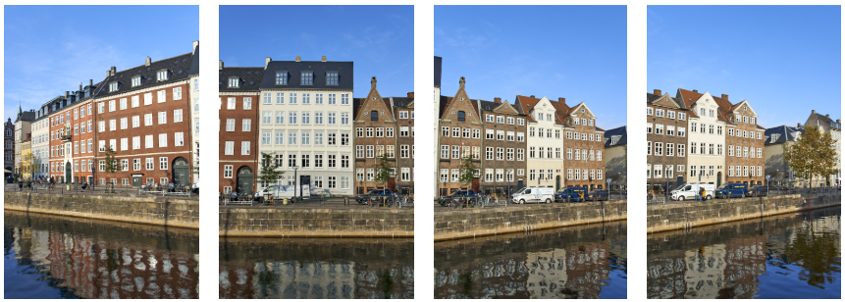
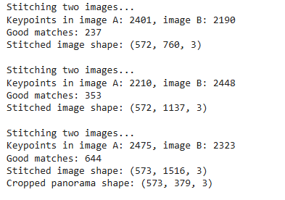
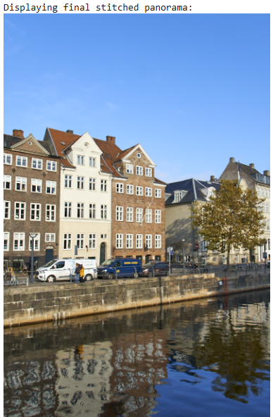

import cv2
import numpy as np
import matplotlib.pyplot as plt

# -----------------------------
# Read images
# -----------------------------
img1 = cv2.imread("image_1.jpeg")
img2 = cv2.imread("image_2.jpeg")
img3 = cv2.imread("wheel.png")
img4 = cv2.imread("grayscale_image.jpeg")

images = [img1, img2, img3, img4]

# Convert to grayscale
gray_images = [cv2.cvtColor(img, cv2.COLOR_BGR2GRAY) for img in images]

# -----------------------------
# SIFT Feature Detector
# -----------------------------
sift = cv2.SIFT_create()

keypoints = []
descriptors = []

for gray in gray_images:
kp, des = sift.detectAndCompute(gray, None)
keypoints.append(kp)
descriptors.append(des)

# -----------------------------
# Feature Matching (BFMatcher)
# -----------------------------
bf = cv2.BFMatcher(cv2.NORM_L2)

def stitch_two_images(imgA, imgB, kpA, kpB, desA, desB):
matches = bf.knnMatch(desA, desB, k=2)

good_matches = []
for m, n in matches:
if m.distance < 0.75 * n.distance:
good_matches.append(m)

if len(good_matches) < 10:
print("Not enough matches!")
return imgA

src_pts = np.float32([kpA[m.queryIdx].pt for m in good_matches]).reshape(-1,1,2)
dst_pts = np.float32([kpB[m.trainIdx].pt for m in good_matches]).reshape(-1,1,2)

H, _ = cv2.findHomography(dst_pts, src_pts, cv2.RANSAC, 5.0)

height, width = imgA.shape[:2]
warped = cv2.warpPerspective(imgB, H, (width*2, height))

warped[0:height, 0:width] = imgA
return warped

# -----------------------------
# Stitch images step-by-step
# -----------------------------
panorama1 = stitch_two_images(images[0], images[1],
keypoints[0], keypoints[1],
descriptors[0], descriptors[1])

panorama2 = stitch_two_images(panorama1, images[2],
sift.detectAndCompute(cv2.cvtColor(panorama1, cv2.COLOR_BGR2GRAY), None)[0],
keypoints[2],
sift.detectAndCompute(cv2.cvtColor(panorama1, cv2.COLOR_BGR2GRAY), None)[1],
descriptors[2])

final_panorama = stitch_two_images(panorama2, images[3],
sift.detectAndCompute(cv2.cvtColor(panorama2, cv2.COLOR_BGR2GRAY), None)[0],
keypoints[3],
sift.detectAndCompute(cv2.cvtColor(panorama2, cv2.COLOR_BGR2GRAY), None)[1],
descriptors[3])

# -----------------------------
# Display Result
# -----------------------------
plt.figure(figsize=(15,6))
plt.imshow(cv2.cvtColor(final_panorama, cv2.COLOR_BGR2RGB))
plt.title("Final Stitched Panorama using SIFT")
plt.axis("off")
plt.show()

